Name: S Jenefar
Reg Num: 192511345
Course: Operating System
Course Code: CSA0403
LAB OUTPUT
Experiment 1
Create a new process by invoking the appropriate system call. Get the process identifier of the currently running process and its respective parent using system calls and display the same using a C program.
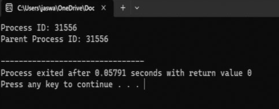
Experiment 2
Identify the system calls to copy the content of one file to another and illustrate the same using a C program
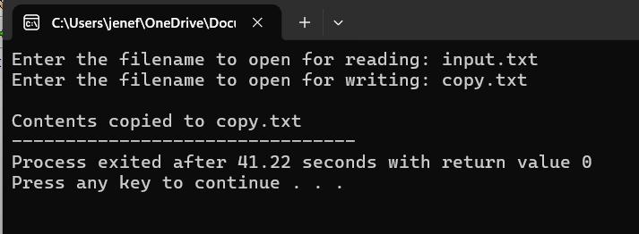
Experiment 3
Design a CPU scheduling program with C using First Come First Served technique with the following considerations.
- All processes are activated at time 0.
- b. Assume that no process waits on I/O devices.
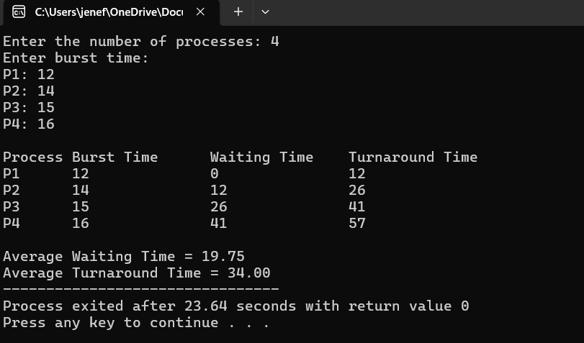
Experiment 4
Construct a scheduling program with C that selects the waiting process with the smallest execution time to execute next.
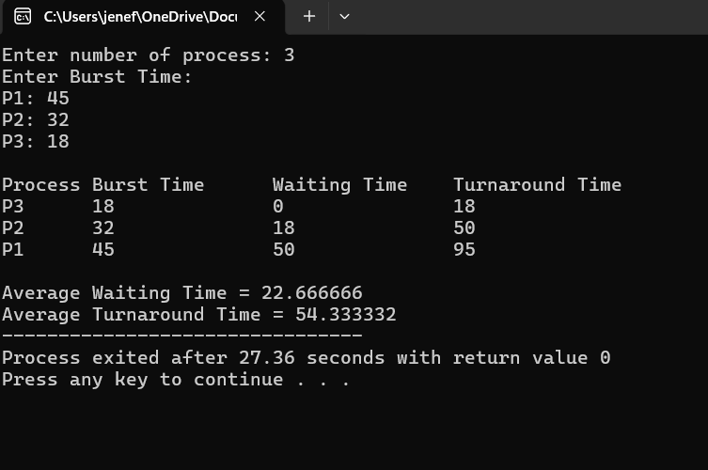

Experiment 5
Construct a scheduling program with C that selects the waiting process with the highest priority to execute next.
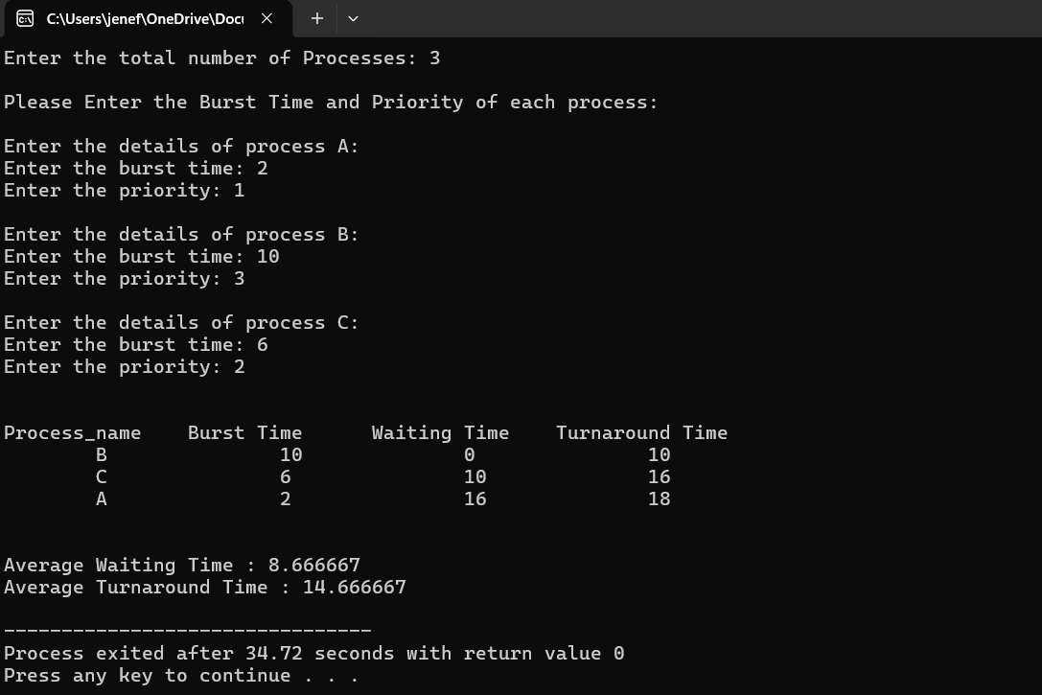
Experiment 6
Construct a C program to simulate Round Robin scheduling algorithm with C.
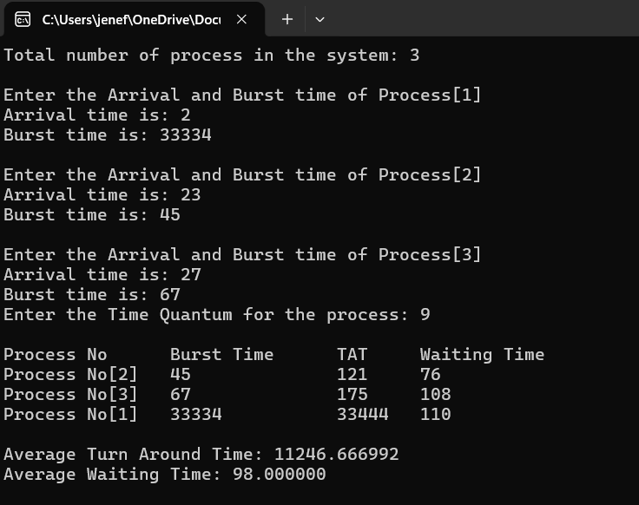

Experiment 7
Construct a C program to implement non-preemptive SJF algorithm
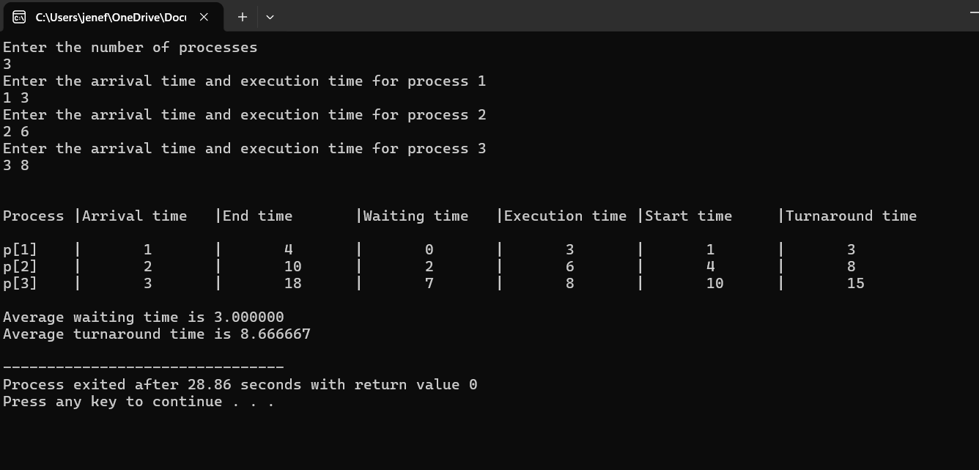
Experiment 8
Construct a C program to simulate Round Robin scheduling algorithm with C.
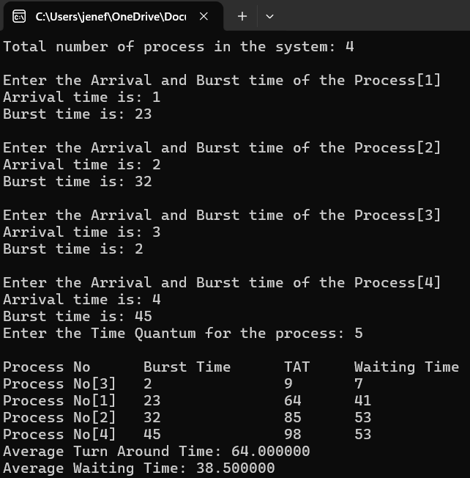

Experiment 9
Illustrate the concept of inter-process communication using shared memory with a C program
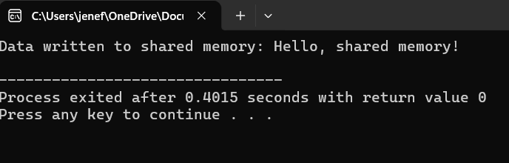

Experiment 10
Illustrate the concept of inter-process communication using message queue with a c program
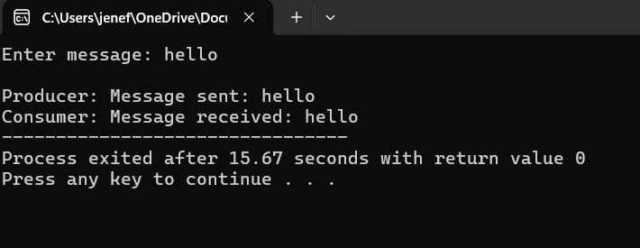
Experiment 11
Illustrate the concept of multithreading using a C program
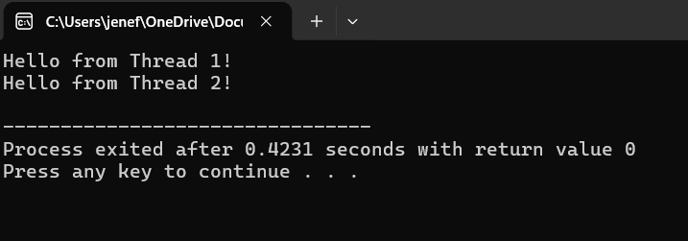

Experiment 12
Design a C program to simulate the concept of Dining-Philosophers problem
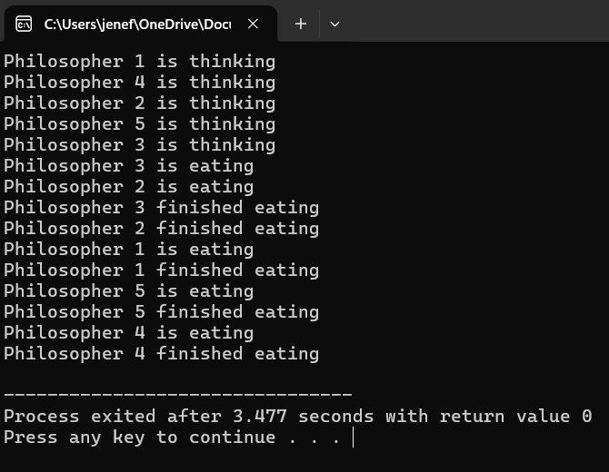
Experiment 13
Construct a C program to implement various memory allocation strategies.
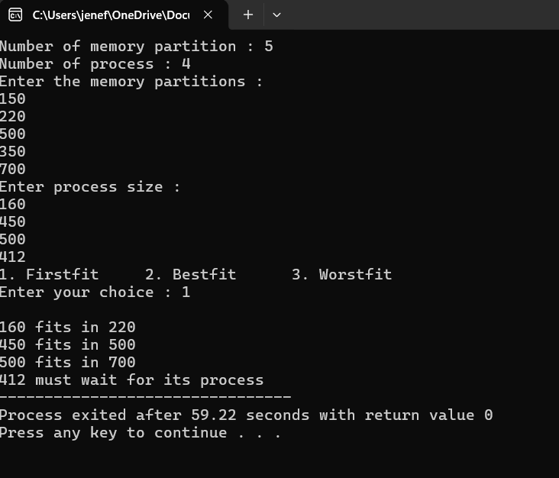
Experiment 14
Construct a C program to organize the file using single level directory
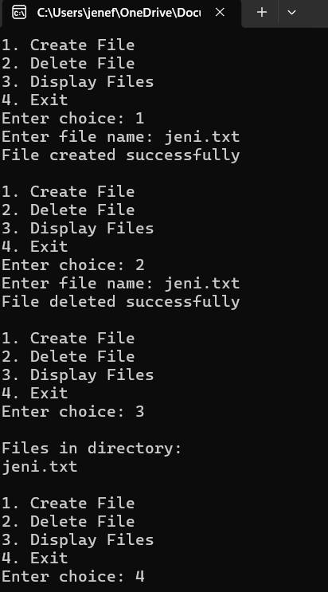
Experiment 15
Design a C program to organize the file using two level directory structure.
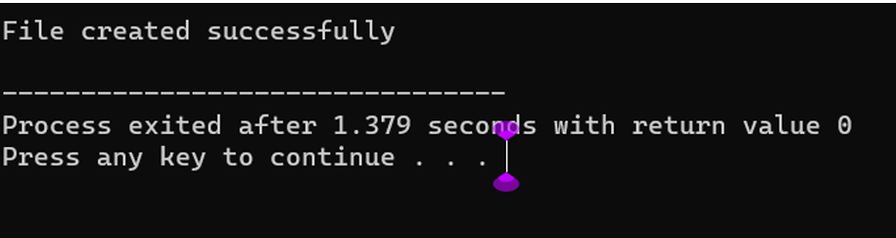

Experiment 16
Develop a C program for implementing random access file for processing the employee details
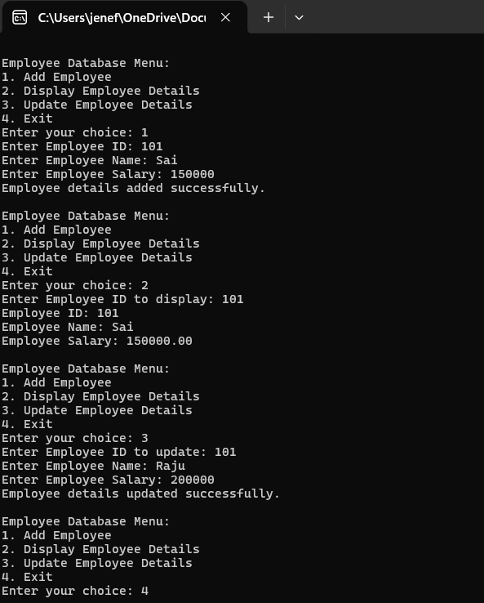
Experiment 17
Illustrate the deadlock avoidance concept by simulating Banker’s algorithm using C.
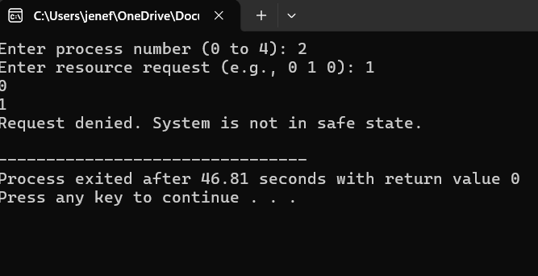

Experiment 18
Construct a C program to simulate producer consumer problem using semaphores.
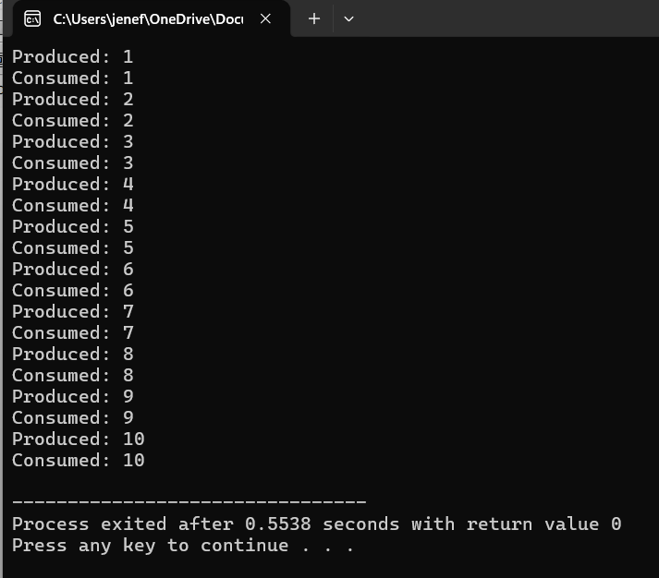
Experiment 19
Design a C program to implement process synchronization using mutex locks
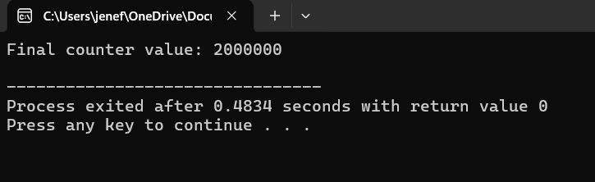

Experiment 20
Construct a C program to simulate Reader-Writer problem using semaphores
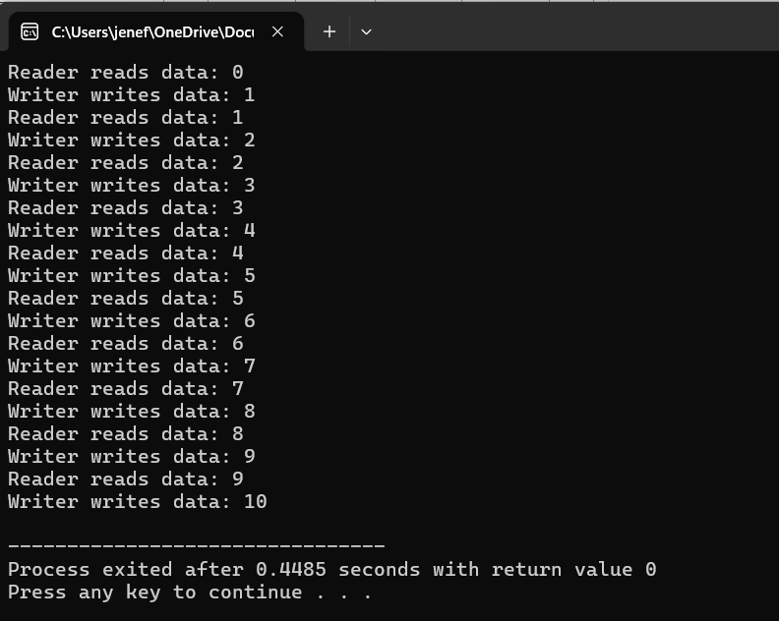
Experiment 21
Develop a C program to implement the worst fit algorithm of memory management.
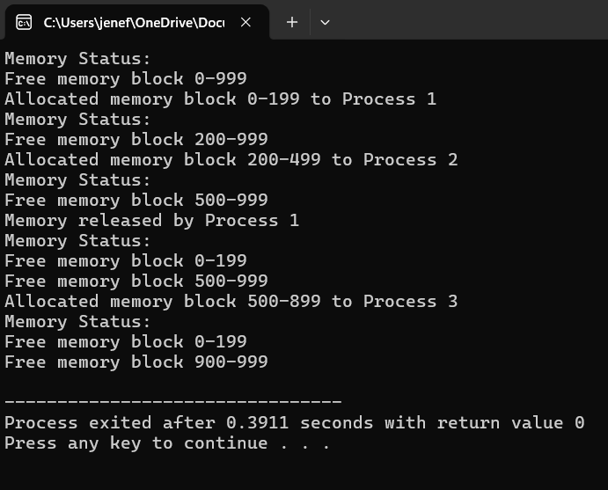

Experiment 22
Construct a C program to implement best fit algorithm of memory management.
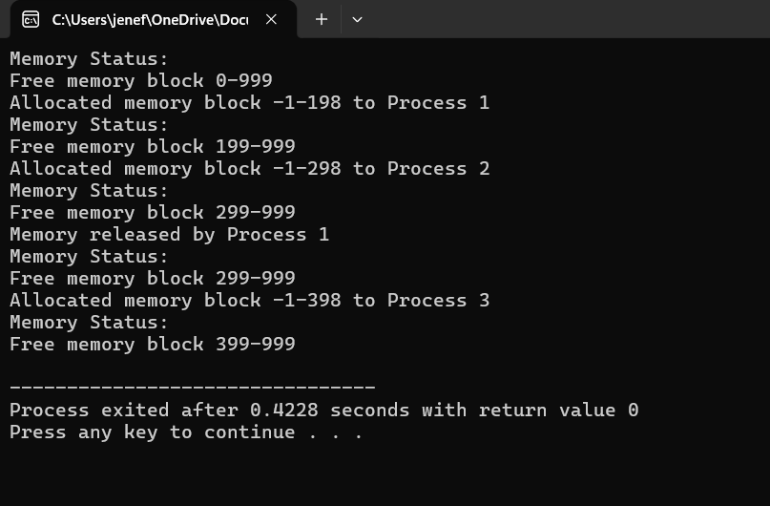
Experiment 23
Construct a C program to implement first fit algorithm of memory management.
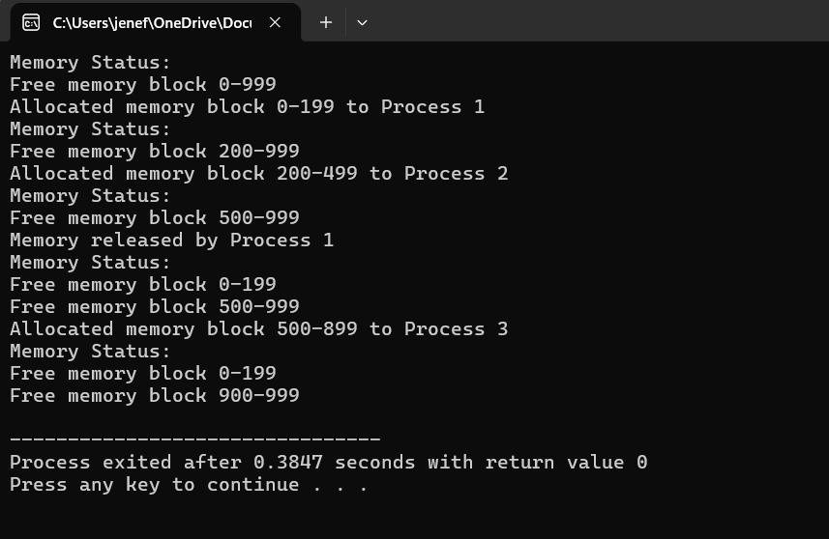

Experiment 24
Design a C program to demonstrate UNIX system calls for file management.
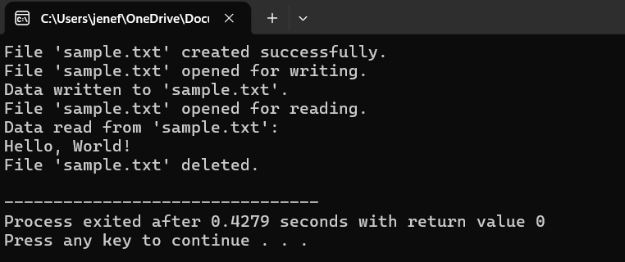
Experiment 25
Construct a C program to implement the I/O system calls of UNIX (fcntl, seek, stat, opendir, readdir)
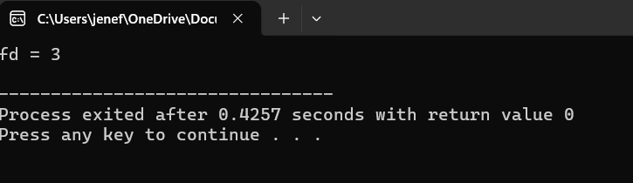
Experiment 26
Construct a C program to implement the file management operations.
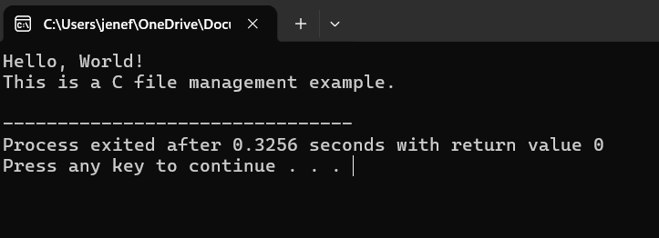

Experiment 27
Develop a C program for simulating the function of ls UNIX Command.
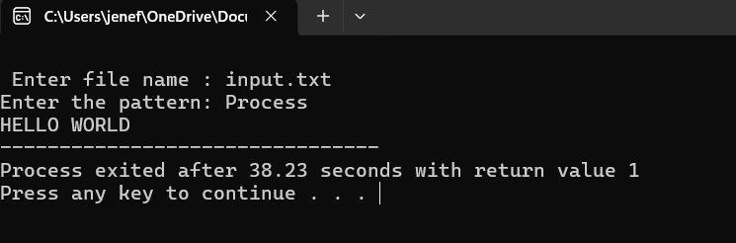

Experiment 28
Write a C program for simulation of GREP UNIX command.
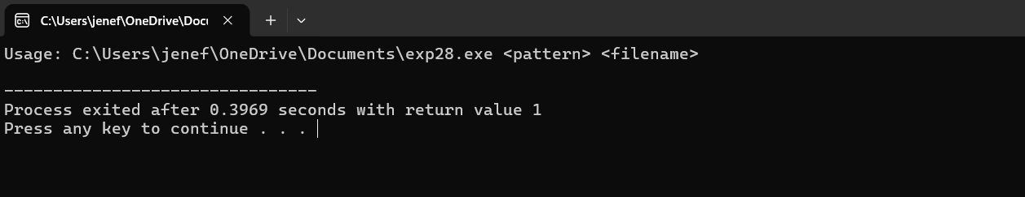
Experiment 29
Write a C program to simulate the solution of Classical Process Synchronization 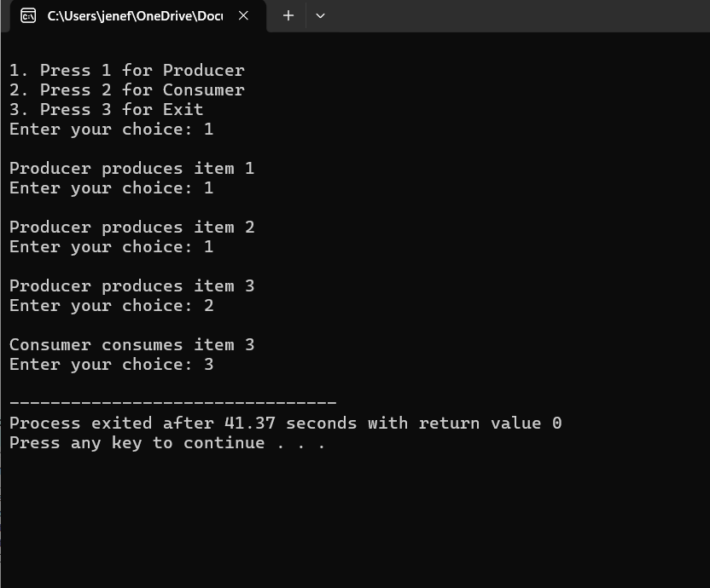
Experiment 30
Write C programs to demonstrate the following thread relatedconcepts.
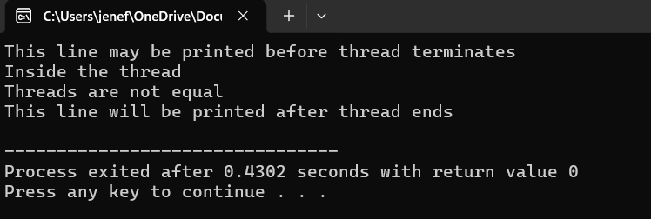
Experiment 31
Construct a C program to simulate the First in First Out paging technique of memory management.
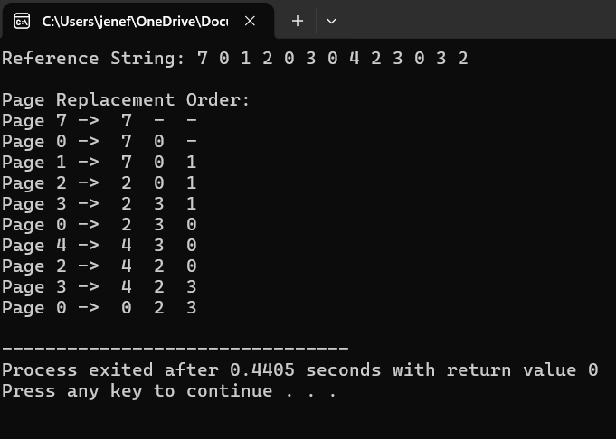

Experiment 32
Construct a C program to simulate the Least Recently Used paging technique of memory management.
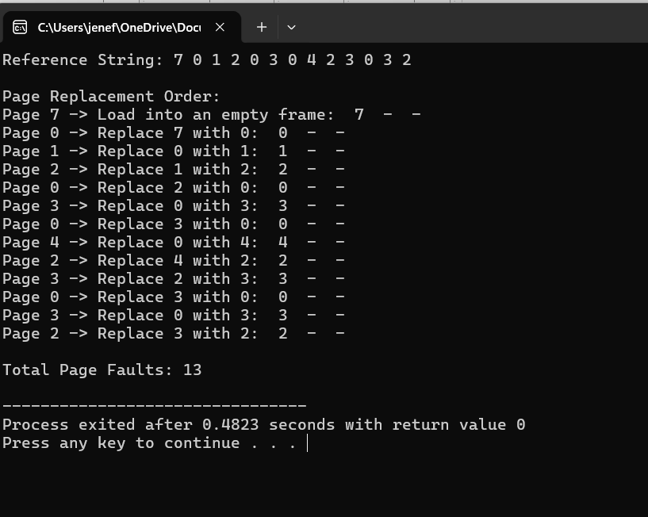
Experiment 33
Construct a C program to simulate the optimal paging technique of memory management
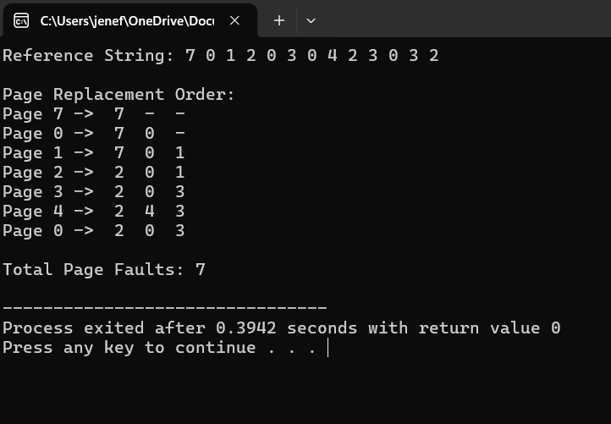
Experiment 34
Consider a file system where the records of the file are stored one after another both physically and logically. A record of the file can only be accessed by reading all the previous records. Design a C program to simulate the file allocation strategy.
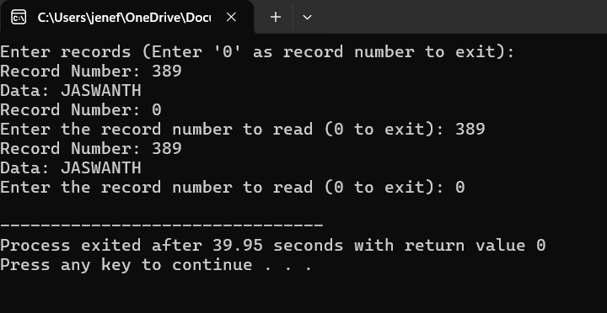
Experiment 35
Consider a file system that brings all the file pointers together into an index block. The ith entry in the index block points to the ith block of the file. Design a C program to simulate the file allocation strategy.
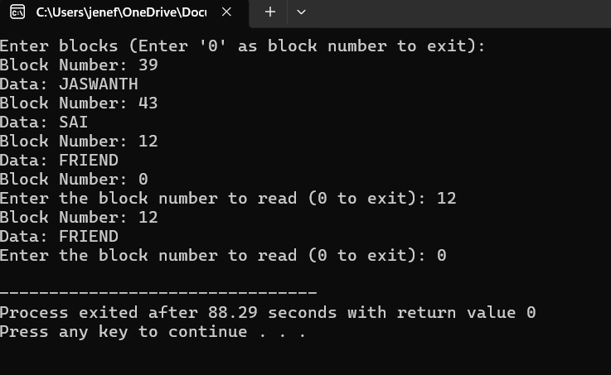
Experiment 36
With linked allocation, each file is a linked list of disk blocks; the disk blocks may be scattered anywhere on the disk. The directory contains a pointer to the first and last blocks of the file. Each block contains a pointer to the next block. Design a C program to simulate the file allocation strategy.
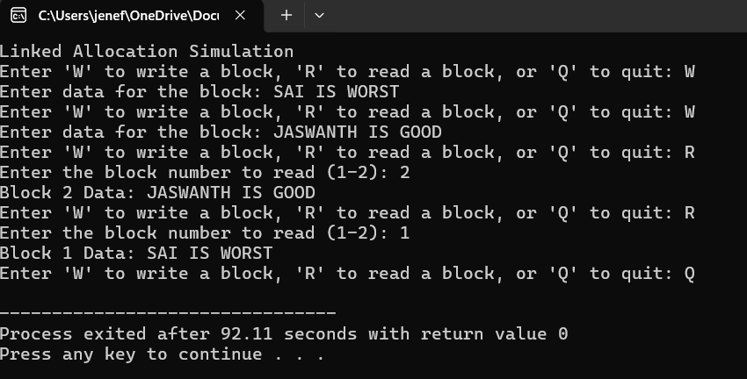
Experiment 37
Construct a C program to simulate the First Come First Served disk scheduling algorithm.
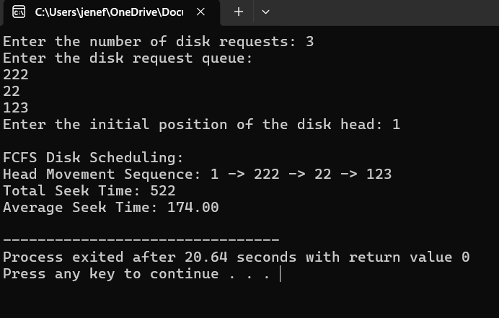

Experiment 38
Design a C program to simulate SCAN disk scheduling algorithm.
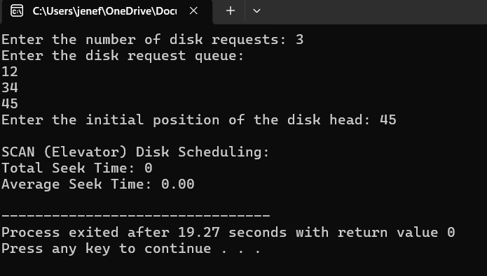
Experiment 39
Develop a C program to simulate C-SCAN disk scheduling algorithm.
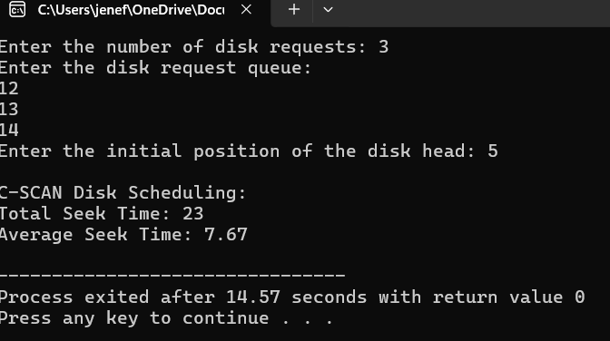

Experiment 40
Illustrate the various File Access Permission and different types users in Linux.
